26.72: The current for full-scale deflection is 0.02 A. From the circuit we can derive three equations:
(i)
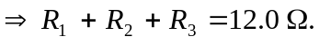
(ii)
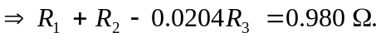
(iii)
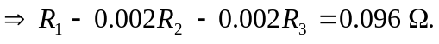
From (i) and (ii) 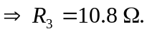
From (ii) and (iii)

